# TRANSCANAL ENDOSCOPIC EAR SURGERY Instrument User-Feedback Study

# Background and Rationale

Middle ear surgery is traditionally performed through an external incision with visualisation of delicate anatomical structures using a microscope.  More recently, minimally invasive ear surgical techniques have been developed using endoscopes to access the middle ear through the ear canal without an external incision [1]. As with open microscope-guided surgery, this transcanal endoscopic ear surgery (TEES) technique, allows the surgeon to perform procedures such as ear drum reconstruction, skin growth removal and hearing bone repair [1] [2] [3]. The advantages of endoscopic ear surgery are as follows: removing the need for an external incision and reducing postoperative morbidity, improving visualisation for disease eradication, including reduction of the rate of residual skin growth (cholesteatoma), and improving hearing by facilitating hearing bone preservation [4] [5] [6].

Despite the enthusiasm of some ear surgeons (otologists), endoscopic ear surgery has not as yet been accepted by all practicing otologists [7].  The principal challenge with TEES is that a one-handed surgical technique is required as the endoscope is held in the other hand.  Otologic instruments were developed for two-handed microscope-guided surgery so they are not optimized for the TEES environment. As otologists have been trained and gained experience in microscope-guided ear surgery, they have developed techniques with the according instruments and have become accustomed to a two-handed surgical approach. By learning different surgical techniques and gaining experience with the endoscope, most surgeons find that they can complete more cases endoscopically [1] [3] [8]. Nevertheless, the learning curve can be slow and frustrating. In the experience of the primary investigator (PI), technological advances in the design of the endoscope, camera and suction dissection instruments have lead to incremental stepwise jumps in this learning curve [9]. There is a knowledge gap in the literature where it is not reported exactly why surgeons have not adopted the technique, and what technological and/or training advances would facilitate its use. It is proposed that in order to facilitate TEES, the needs of surgeons and current limitations of tools must be determined.

Over the past two years, we have studied this problem and new technologies have been developed to facilitate TEES. In order to translate the benefits of this technology and develop it into a useful surgical tool, surgeon-user feedback on the design of this new instrument is required. The purpose of this study is to rank the features of the instrument’s design and collect feed-back on the features needing improvement.

# Objectives and Goals

The objective of this study is to collect surgeon-user feedback on the design of new TEES instruments developed at the Hospital for Sick Children. The study will consider the use of the tools in basic bench-top pick-and-place maneuvers and also while using the tools along with standard instruments while performing a “mock” surgery using 3D printed ear anatomical modelsThe ultimate goal of this research is to incorporate human factors into the continuing design of the instrument.

# methods

## Study Setting

This single-center study will take place at the Surgical Skills Center in Toronto, Canada. The center will provide standard TEES equipment to compliment the instrument being tested.

## Study population/Demographics

A total of 24 participants will be recruited for the user-feedback study and will include ENT residents with varying levels of experience (novice), neurosurgical fellows (experienced) and staff surgeons (experts).

## Data Collection

A total of 24 ENT residents and fellow/staff neurosurgeons will perform TEES maneuvers using the new instrument in conjunction with standard clinical equipment on 3D printed ear anatomical models.

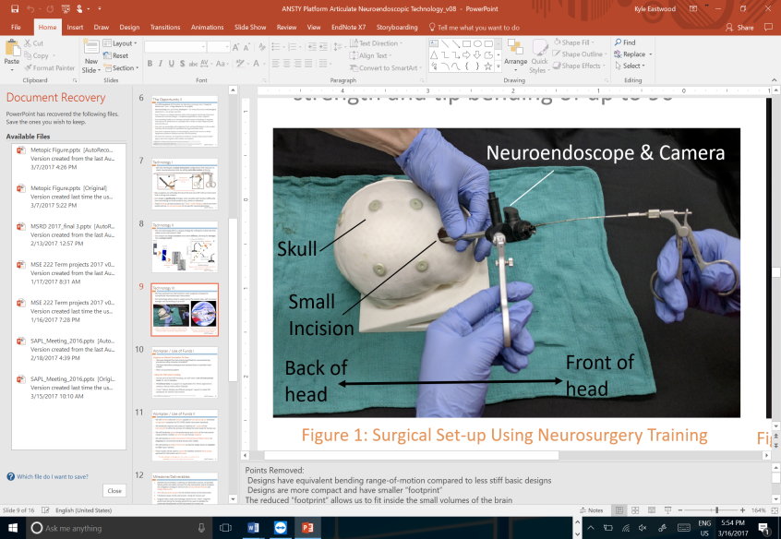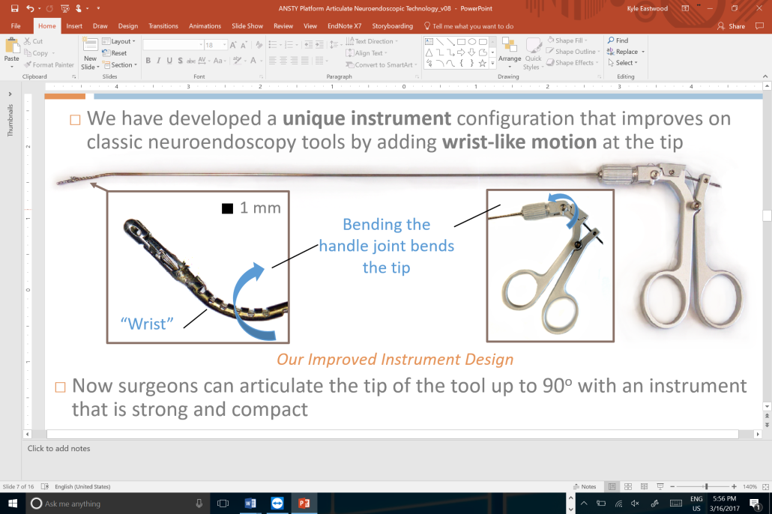

Figure 1: Example of Neurosurgical Simulator Set-up with Synthetic Brain Model and Neuroendoscopic Instruments [Left]. Example of New Instrument with “Wrist” to be Tested in Survey

Using a mixed-methods design, all participants will complete a 30-item questionnaire (5-point Likert scales) to rate the design features of the instrument and will also provide feedback for each item. The survey will also include six separate questions regarding demographics and prior experience, as well as a final overall impressions section. Specifically, the 24-item questionnaire considers the instrument handle’s form and feel (Items 7-9), the rating of instrument’s ease-of-use alongside existing standard equipment (Items 10-17), the rating of the instrument’s performance (Items 18-24) and the tool’s comfort (Items 25-30). An example of the survey is included in the appendix. All of the information will be stored on a secure server and anonymized.

## Study Limitations

The first limitation of the study design is that some of the participants (junior residents in years 1-3) will have limited experience using standard neuroendoscopic instruments. This issue will limit their ability to evaluate the differences between the new instrument and existing tools. Additionally, participants will be subject to recall bias when comparing the use of the tool for the simulated surgery to previous actual surgical experiences. Finally, the sample size of the study may be small, particularly for conducting any sub-group analysis to compare differences in responses between surgeons of different experience levels, such as the staff and trainees.

# DATA ANALYSIS PROCEDURES

The collected data consists of ordinal categorical variables (Likert: Strongly Disagree, Disagree, Neutral, Agree, Strongly Agree) grouped into four themes. This information will be collected from three evaluator subgroups (nominal data) that are defined by levels of experience: Novice (Residents in post-graduate years 1-6), experienced (Fellows) and experts (staff neurosurgeons). The pooled results of each of the twelve items will be presented as frequencies in a contingency table. To more succinctly summarize the four themes, the mean, standard deviation and median ratings of the handle’s form and feel (Items 7-9), the instrument’s ease-of-use (Items 10-17), the instrument’s performance (Items 18-24) and the tool’s comfort (Items 25-30). will be calculated.

A subgroup analysis will also be conducted for the two evaluator groups to identify any statistically significant differences in the instrument’s assessments based on surgical experience. The Kruskall-Wallis test, which is a non-parametric one-way analysis of variance, will be considered (assuming a 95% confidence interval) to test whether the novice, experienced and expert responses originate from the same distribution. For any questionnaire items that are found to have a p-value less than 0.05, the Mann-Whitney U test, which is considered a non-parametric alternative to the independent t-test, will be used to perform a multiple comparison of means. The p-values in the multiple comparisons analysis will be adjusted using the method of Benjamini-Hochberg (BH) which aims to control the false discovery rate. This adjustment will be compared to the un-adjusted p-values. All analysis will be completed using R version 3.2.0 (The R Foundation).

The qualitative feedback obtained from the surveys will be organized by the same themes, which include instrument’s handle’s form and feel, the instrument’s ease-of-use, the instrument’s performance, and the tool’s comfort. The responses will be coded and recurring items will be grouped. Any coded items that occurred more than three times will be explicitly tabulated and discussed in the results.